Chain of Resp  
  
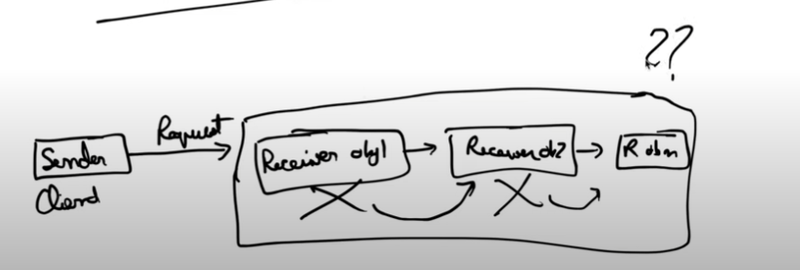  
  
This is used when a request is sent and we don’t know which receiver will full fill this request

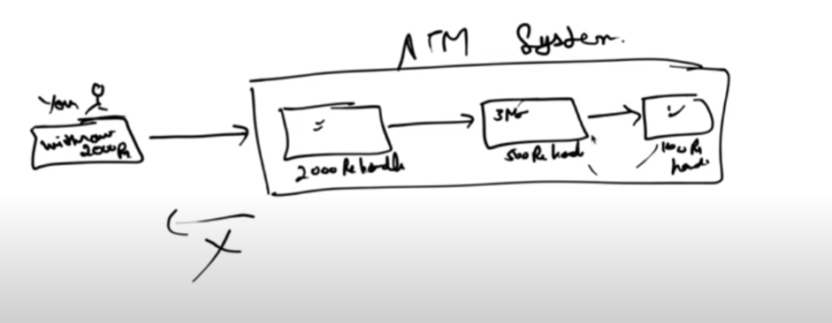

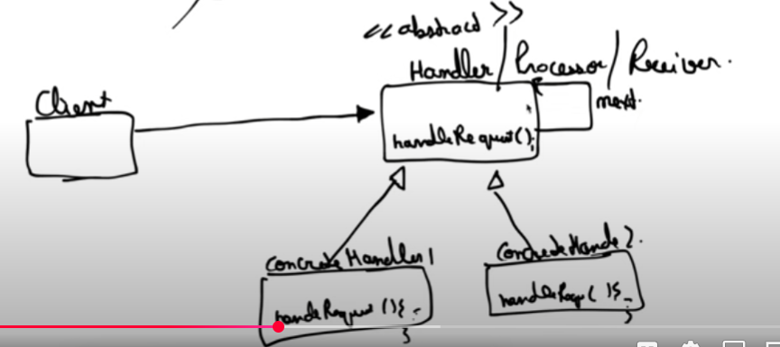  
  
If one handler cannot process the incoming request the request would go to the next handler.

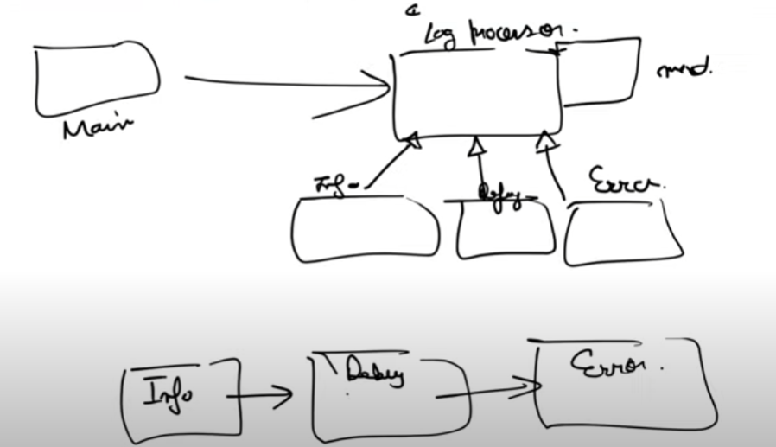  
  
LogProcessor abstract class is used to store the nextLogProcessor class